MCMD Problem Structure

Name

Course Title and Number
Professor’s Name
Date
MCMD Problem Structures
The paper aims at providing solution to an issue regarding the best accounting software system to be installed for accounting functions within a firm. The major characteristics that are used to make selection on the software include the cost, reliability and functionality. The characteristics have been chosen under the consideration of the five Criteria characteristics used include completeness, Redundancy, operationality, mutual independence of criteria and number of criteria. The four alternatives include Zoho, ClearBooks, Quickbooks and Xero. Therefore the objective of the procedure is to select the most suitable accounting system. The criteria include: cost, reliability and functionality. The alternatives being examined include: Zoho, ClearBooks, Quickbooks and Xero
Reliability and functionality are the qualitative characteristics to be used in the assessment of the four accounting software systems. Cost acts the quantitative measure as this can be addressed numerically. The objective of the procedure is to select the most suitable accounting system. The criteria include: cost, reliability and functionality. The alternatives being examined include: Zoho, ClearBooks, Quickbooks and Xero. Completeness has been adhered to as all the important criteria have been included in making the selection. Under redundancy, any less important aspects have not been included and with repetition being avoided. The four criteria used can be judged effectively under the four alternative thus facilitating operationality. There exists a mutual independence of the criteria. With their number being maintained at three to facilitate effective formulation of the best choice.

Step One: Hierarchy
Accounting System Selection
Reliability
Cost
Functionality
Zoho
Clearbooks
Quickbooks
Xero
Zoho
Clearbooks
Quickbooks
Xero
Zoho
Clearbooks
Quickbooks
Xero

Step Two: Establishing Priorities
- Cost is two times as important as functionality
- Reliability is three times as important as functionality
- Reliability is four times as important as cost
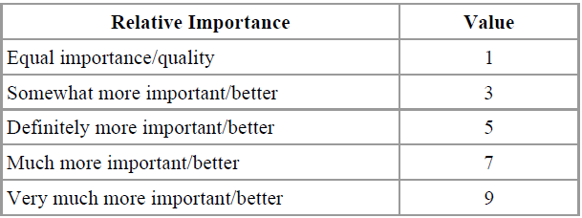

Pairwise Comparison
 | Reliability | Cost | Functionality
Reliability | 1/1 | 4/1 | 3/1
Cost | 1/4 | 1/1 | 2/1
Functionality | 1/3 | 1/2 | 1/1

Step Three: Calculating rating
 | Reliability | Cost | Functionality
Reliability | 1.0000 | 4.0000 | 0.3333
Cost | 0.2500 | 1.0000 | 0.5000
Functionality | 0.3333 | 0.5000 | 1.0000

Computing Sum of each column
 | Reliability | Cost | Functionality
 | 1.0000 | 4.0000 | 0.3333
 | 0.2500 | 1.0000 | 0.5000
 | 0.3333 | 0.5000 | 1.0000
Col_Sum | 1.5833 | 5.5000 | 1.8333

Division of entry by Column Sum
 | Reliability | Cost | Functionality
 | 0.632 | 0.727 | 0.182
 | 0.158 | 0.182 | 0.273
 | 0.210 | 0.091 | 0.545
Col_Sum | 1.000 | 1.000 | 1.000

Establishing priority vector
 | Reliability | Cost | Functionality | Priority Vector
Reliability | 0.632 | 0.727 | 0.182 | 0.514
Cost | 0.158 | 0.182 | 0.273 | 0.204
Functionality | 0.210 | 0.091 | 0.545 | 0.282
Col_Sum | 1.000 | 1.000 | 1.000 | 1.000

Therefore, from the above analysis on the criterion weight, conclusion can be made that:
- RELIABILITY represents 51% of the final decision.
- COST represents 20% of the final decision.
- FUNCTIONALITY represents 28% of the final decision.
Accounting System Selection
Reliability
Cost
Functionality
Zoho
Clearbooks
Quickbooks
Xero
Zoho
Clearbooks
Quickbooks
Xero
Zoho
Clearbooks
Quickbooks
Xero
0.51
0.28
0.20
Step Four: Alternatives Comparison
Reliability
 | Zoho | Clearbooks | Quickbooks | Xero
Zoho | 1/1 | 3/1 | 1/5 | 4/1
Clearbooks | 1/3 | 1/1 | 1/4 | 1/4
Quickbooks | 5/1 | 4/1 | 1/1 | 3/1
Xero | 1/4 | 2/1 | 1/3 | 1/1

 | Zoho | Clearbooks | Quickbooks | Xero
Zoho | 1.00 | 3.00 | 0.20 | 4.00
Clearbooks | 0.33 | 1.00 | 0.25 | 0.25
Quickbooks | 5.00 | 4.00 | 1.00 | 0.33
Xero | 0.25 | 2.00 | 0.33 | 1.0000
Col sum | 6.58 | 10 | 1.78 | 5.58

 | Zoho | Clearbooks | Quickbooks | Xero | Priority Ve
Zoho | 0.15 | 0.30 | 0.11 | 0.71 | 0.32
Clearbooks | 0.05 | 0.10 | 0.14 | 0.04 | 0.08
Quickbooks | 0.76 | 0.40 | 0.56 | 0.06 | 0.45
Xero | 0.04 | 0.20 | 0.19 | 0.18 | 0.15
Col sum | 1 | 1 | 1 | 1 | 1

COST
 | Zoho | Clearbooks | Quickbooks | Xero
Zoho | 1/1 | 1/3 | 3/1 | 1/2
Clearbooks | 3/1 | 1/1 | 5/1 | 4/1
Quickbooks | 1/3 | 1/5 | 1/1 | 1/3
Xero | 2/1 | 1/4 | 3/1 | 1/1

 | Zoho | Clearbooks | Quickbooks | Xero
Zoho | 1.00 | 0.33 | 3.00 | 0.50
Clearbooks | 3.00 | 1.00 | 5.00 | 4.00
Quickbooks | 0.33 | 0.20 | 1.00 | 0.33
Xero | 2.00 | 0.25 | 3.00 | 1.00
Col_Sum | 6.33 | 1.78 | 12 | 5.83

 | Zoho | Clearbooks | Quickbooks | Xero | Priority Ve
Zoho | 0.16 | 0.18 | 0.25 | 0.09 | 0.68
Clearbooks | 0.47 | 0.56 | 0.42 | 0.83 | 0.57
Quickbooks | 0.05 | 0.11 | 0.08 | 0.06 | 0.07
Xero | 0.32 | 0.14 | 0.25 | 0.17 | 0.22
Col sum | 1 | 1 | 1 | 1 | 1

FUNCTIONALITY
 | Zoho | Clearbooks | Quickbooks | Xero
Zoho | 1/1 | 5/1 | 1/2 | 3/1
Clearbooks | 1/5 | 1/1 | 1/6 | 1/3
Quickbooks | 2/1 | 6/1 | 1/1 | 4/1
Xero | 1/3 | 3/1 | 1/4 | 1/1

 | Zoho | Clearbooks | Quickbooks | Xero
Zoho | 1.00 | 5.00 | 0.50 | 3.00
Clearbooks | 0.20 | 1.00 | 0.17 | 0.33
Quickbooks | 2.00 | 6.00 | 1.00 | 4.00
Xero | 0.33 | 3.00 | 0.25 | 1.00
Col_Sum | 3.53 | 15.00 | 1.92 | 8.33

 | Zoho | Clearbooks | Quickbooks | Xero | Priority Ve
Zoho | 0.28 | 0.33 | 0.26 | 0.36 | 0.31
Clearbooks | 0.06 | 0.06 | 0.09 | 0.04 | 0.06
Quickbooks | 0.57 | 0.40 | 0.52 | 0.48 | 0.49
Xero | 0.09 | 0.20 | 0.13 | 0.12 | 0.13
Col sum | 1 | 1 | 1 | 1 | 1

MATRIX ALGEBRA

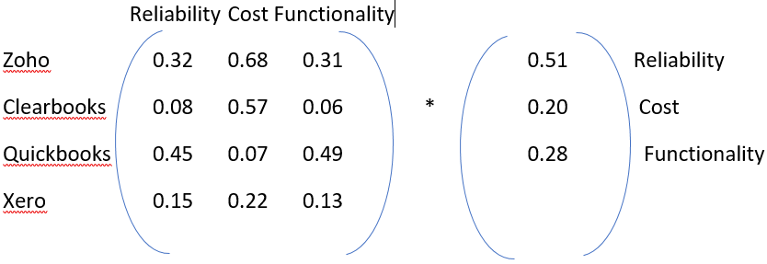
On computing the matrix
Zoho =0.3860
Clearbook =0.1716
Quickbooks =0.3807
Xero =0.1569

Therefore, of all the four alternative, ZOHO WINS as the best accounting software.

